**Selenium Hands-on:**

**Day1 Tasks:**

**Browser Launch Tasks:**

**Facebook Login:**

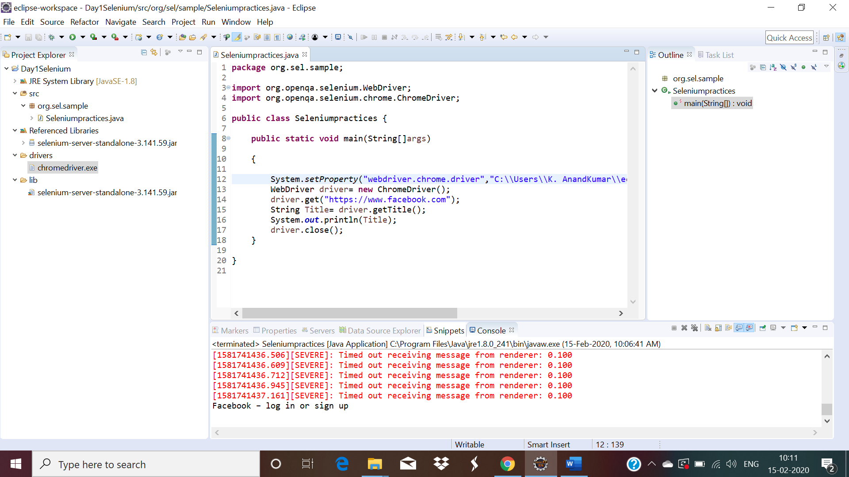

**Greens Technology:**

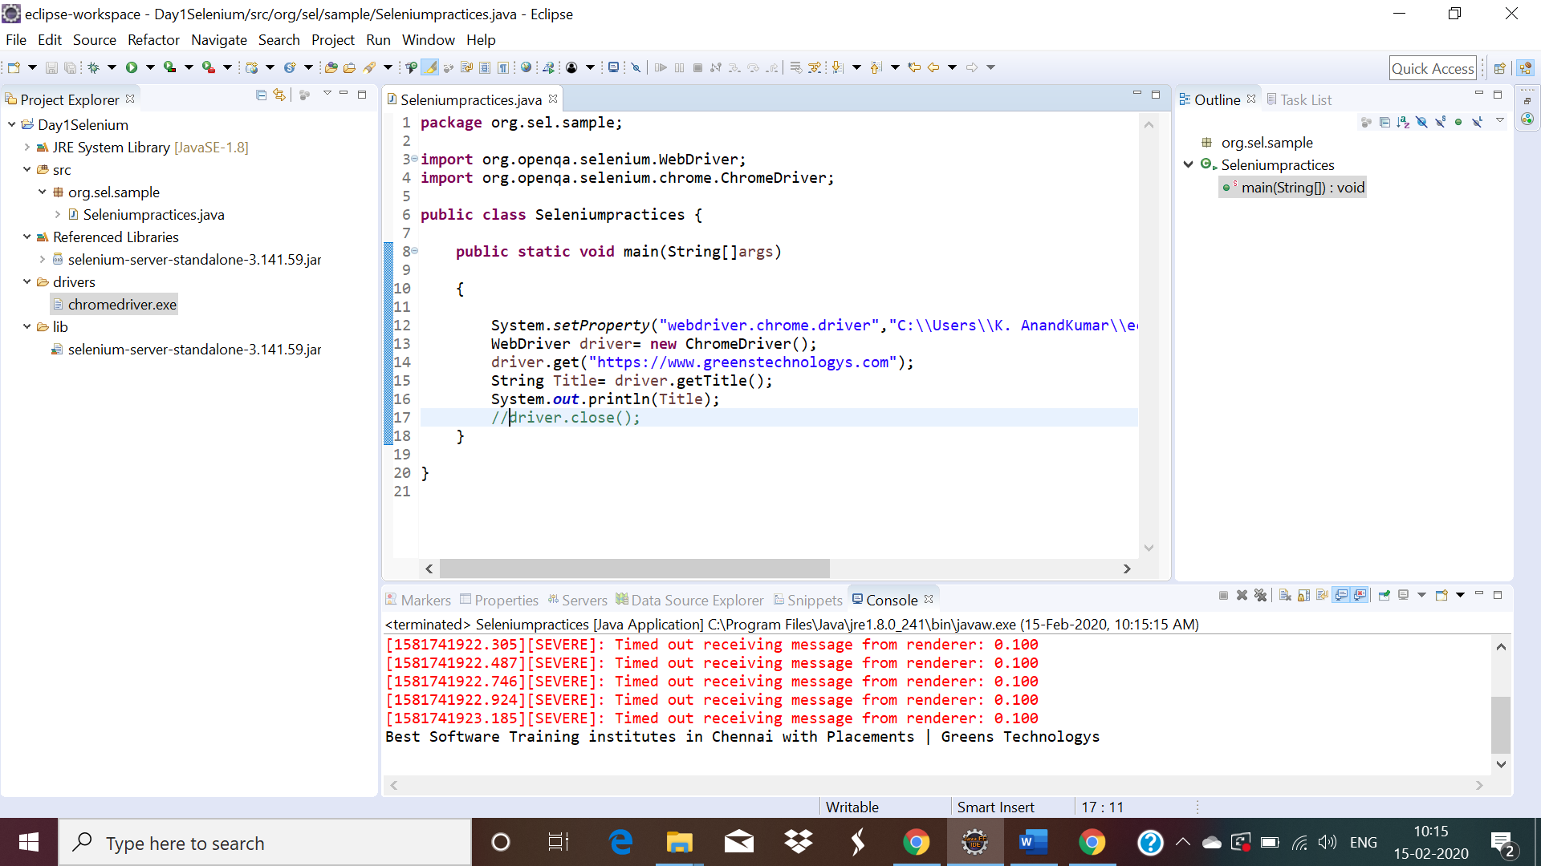

Amazon:

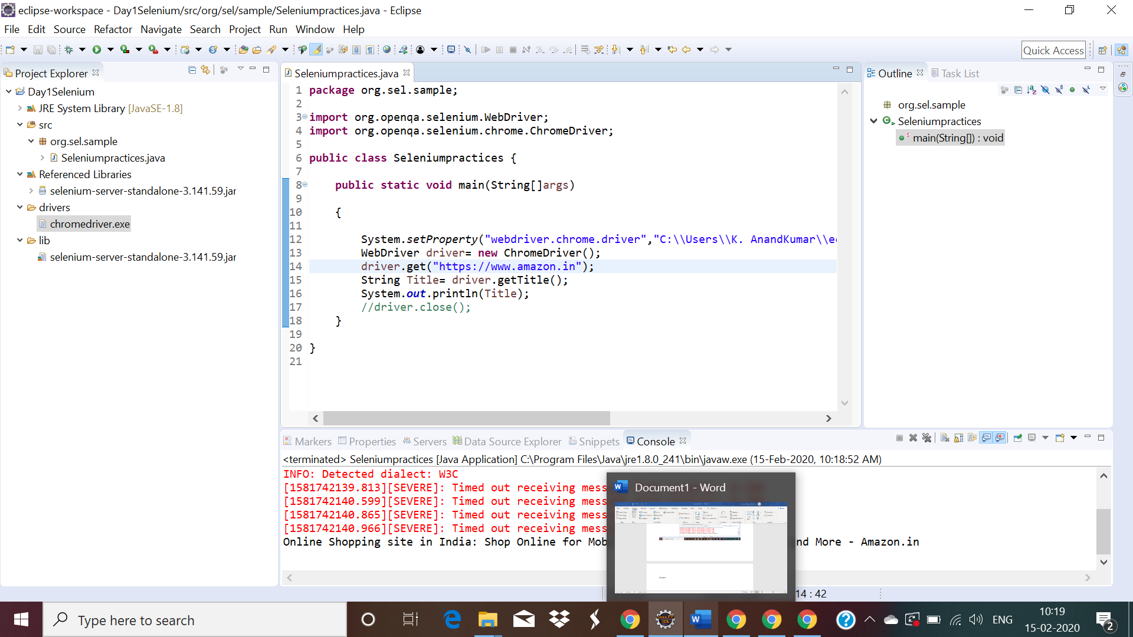

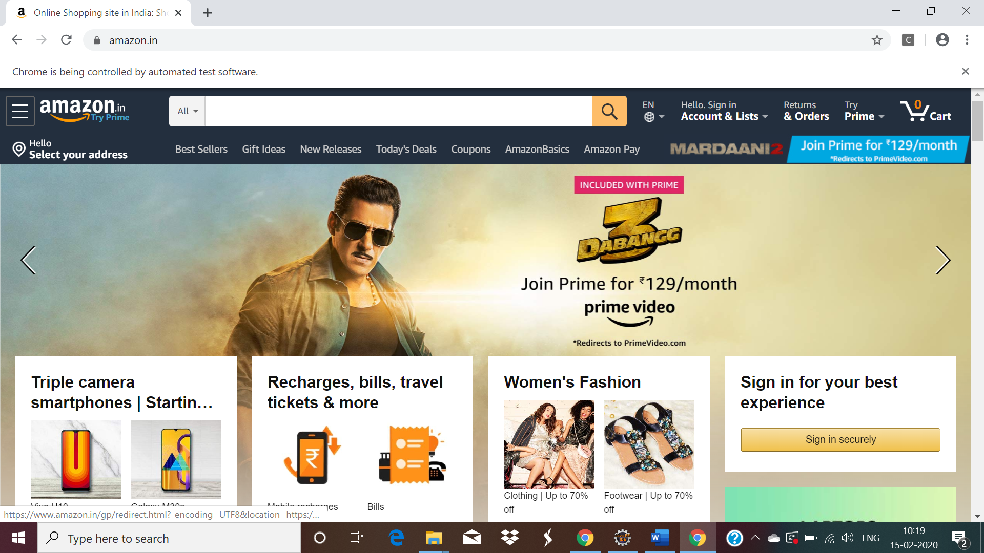

Day 3 Task:

QUESTION 1

-----------

URL : http://www.greenstechnologys.com/

NOTE: Click Contact us. Give the details for submit your enquiry form.

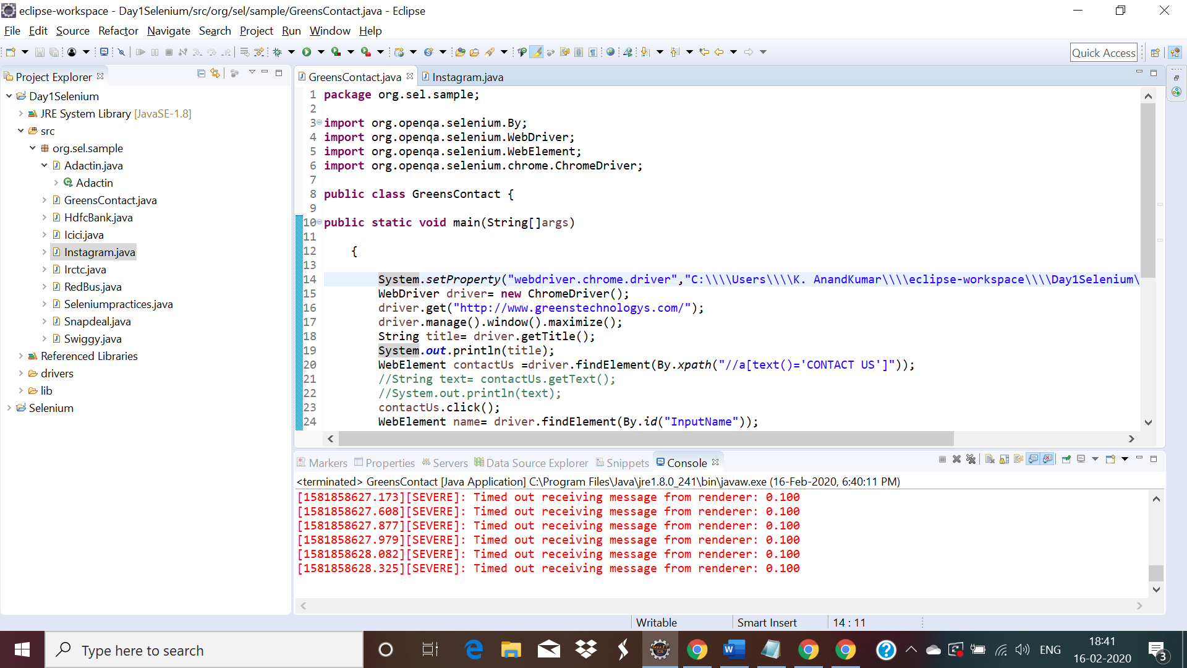

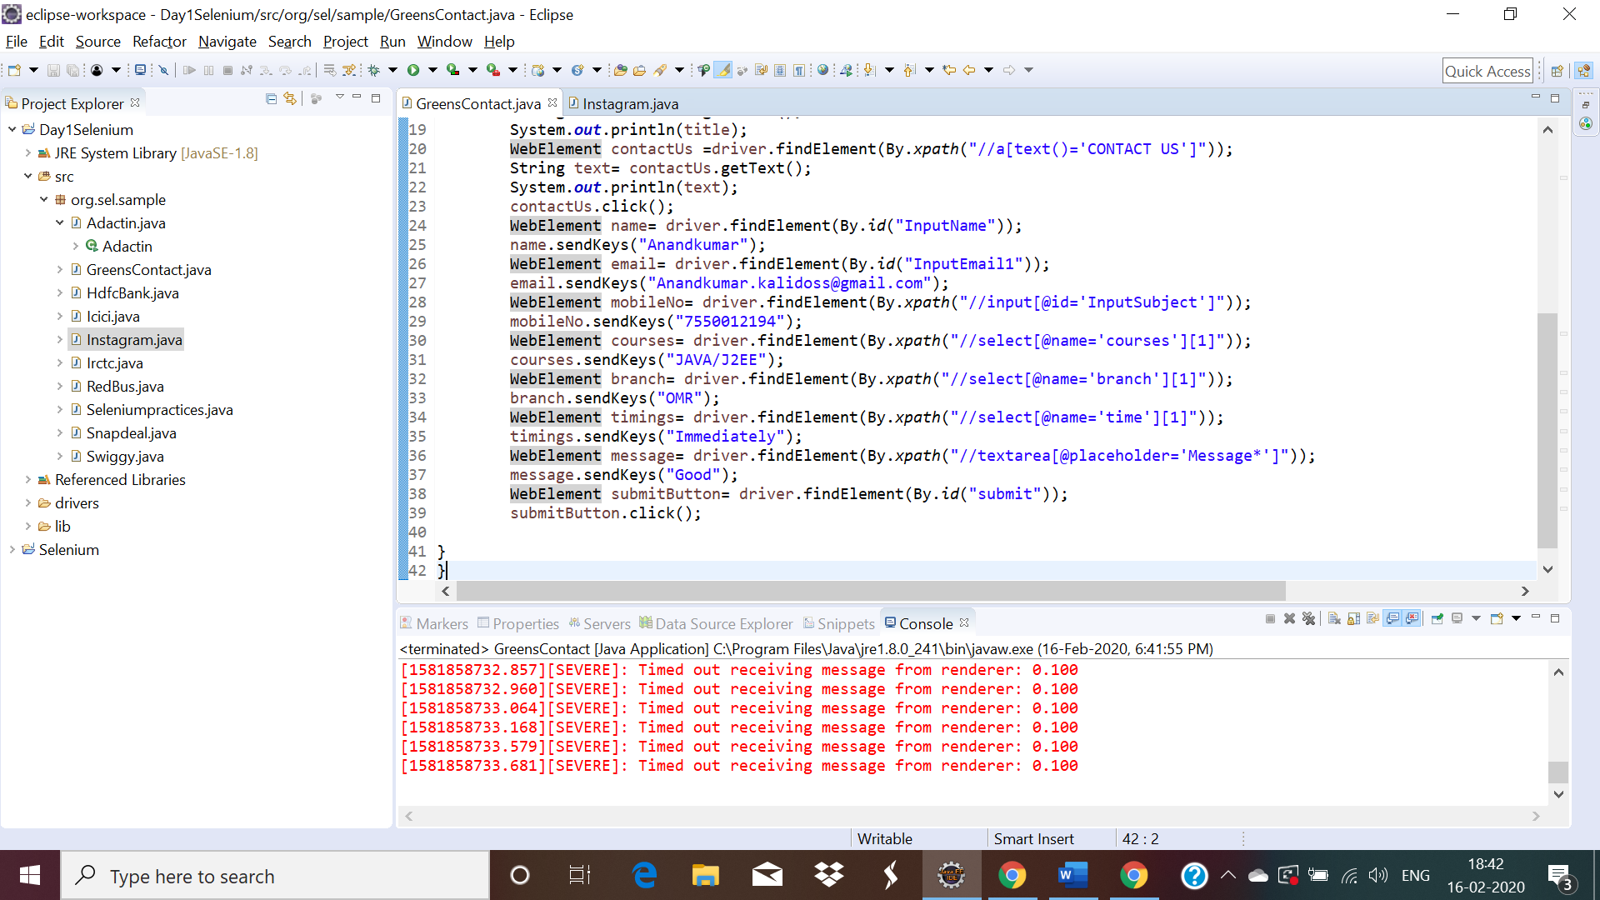

Successfully form submitted.

QUESTION 2

-----------

URL : https://www.facebook.com/

NOTE: Enter email and password and click login(by using xpath locator).

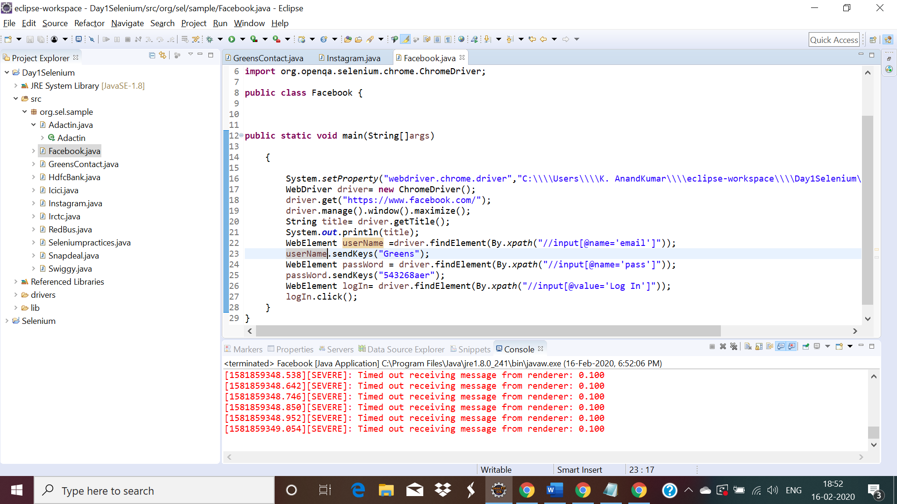

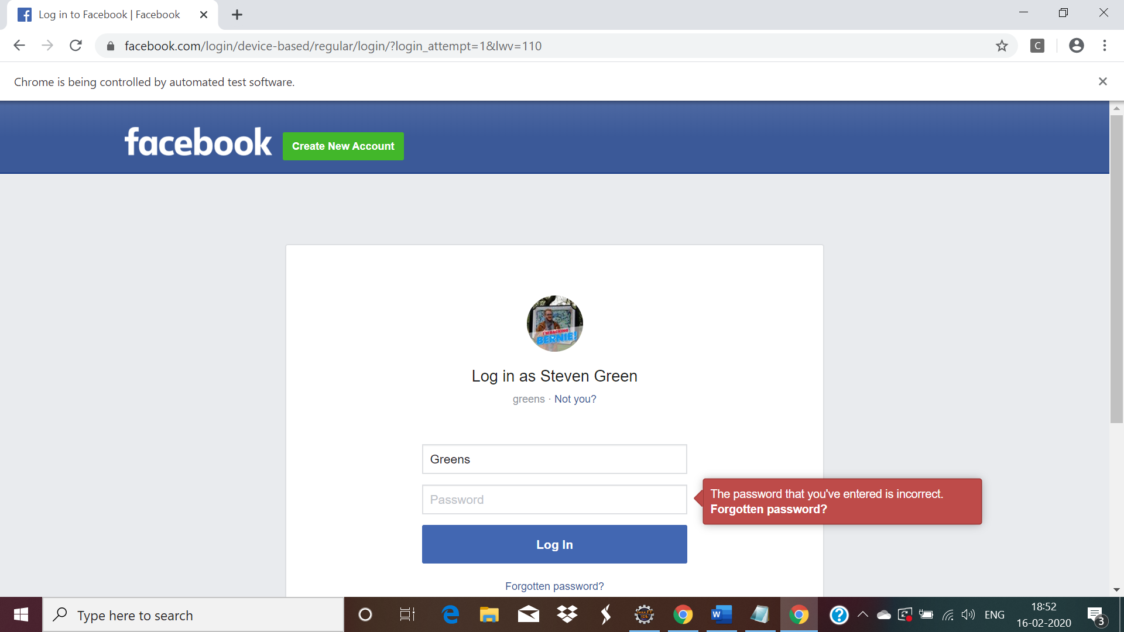

QUESTION 3

-----------

URL : http://demo.automationtesting.in/Register.html

NOTE: Give details and register the form.

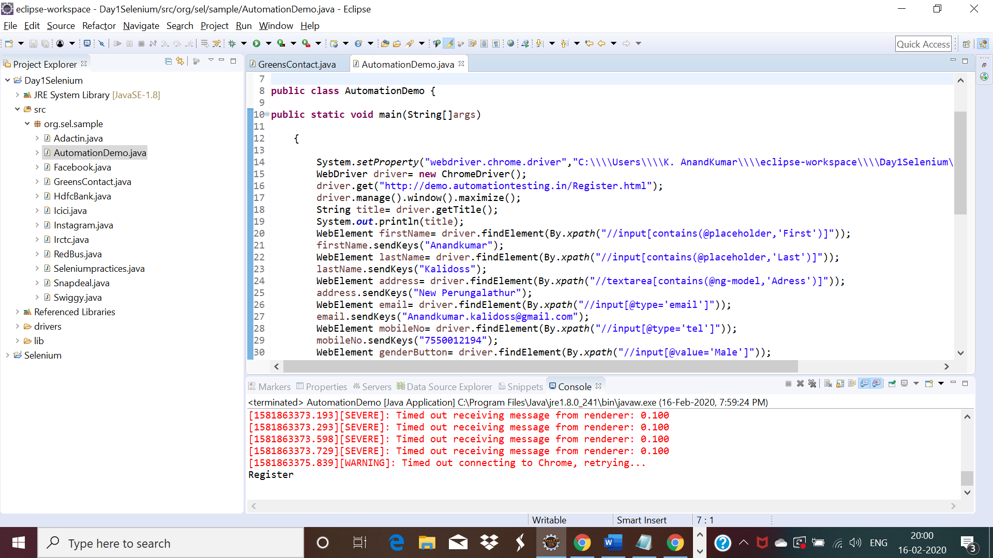

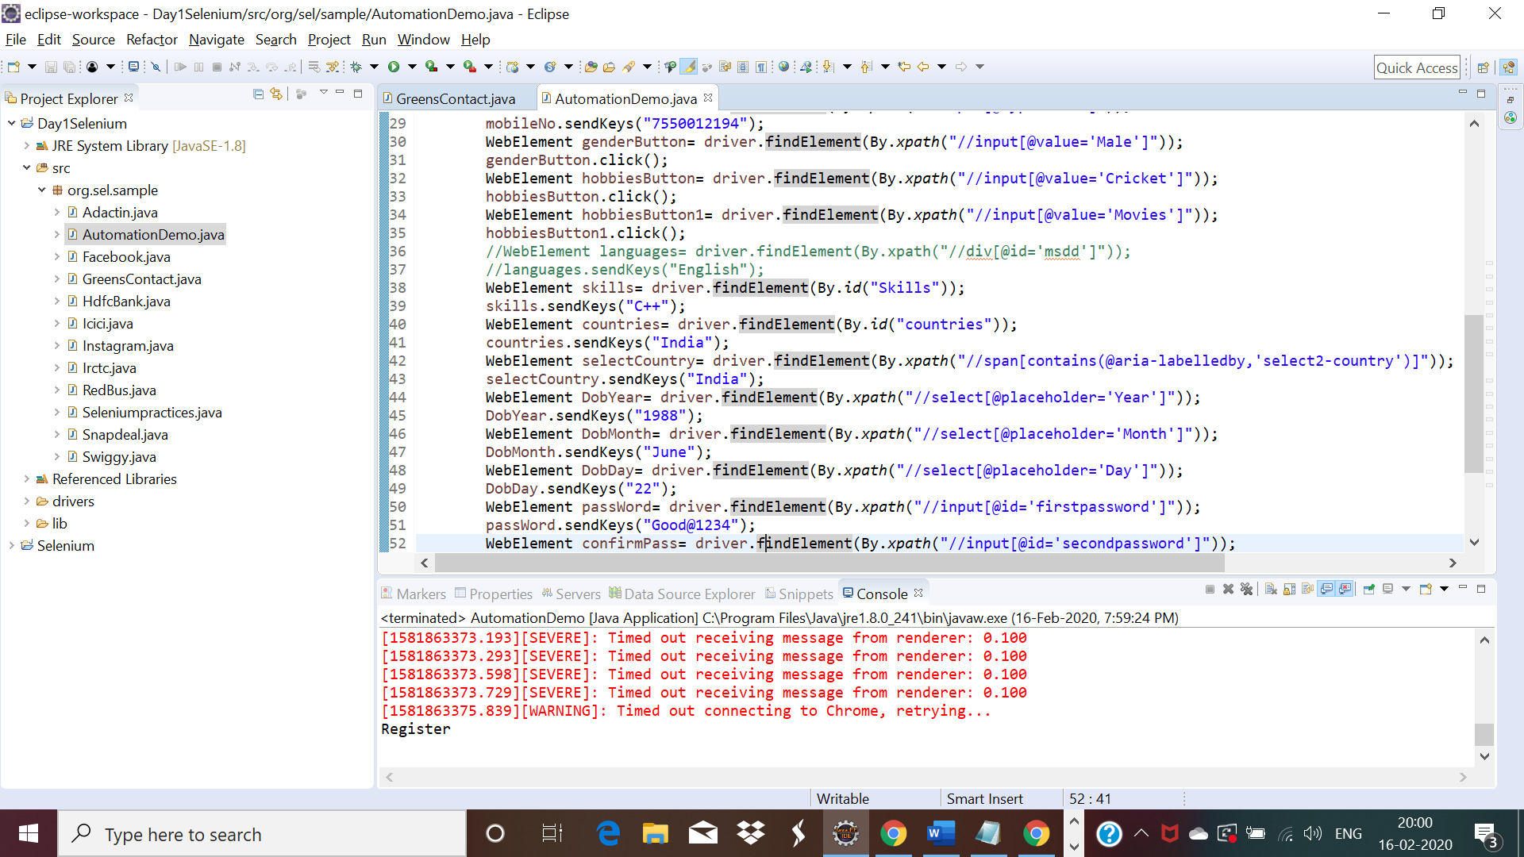

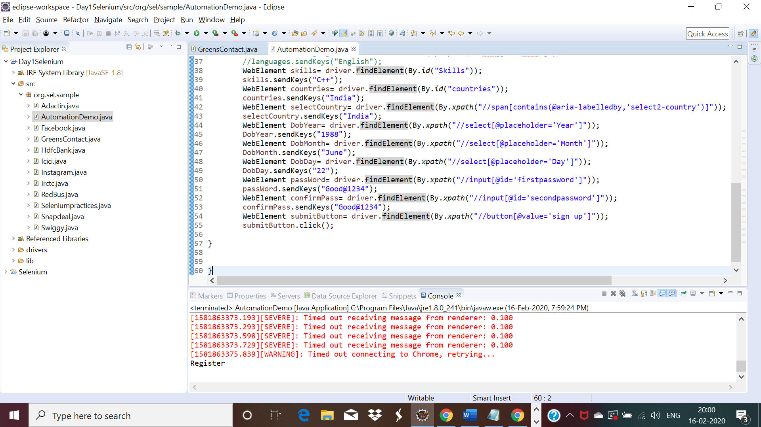

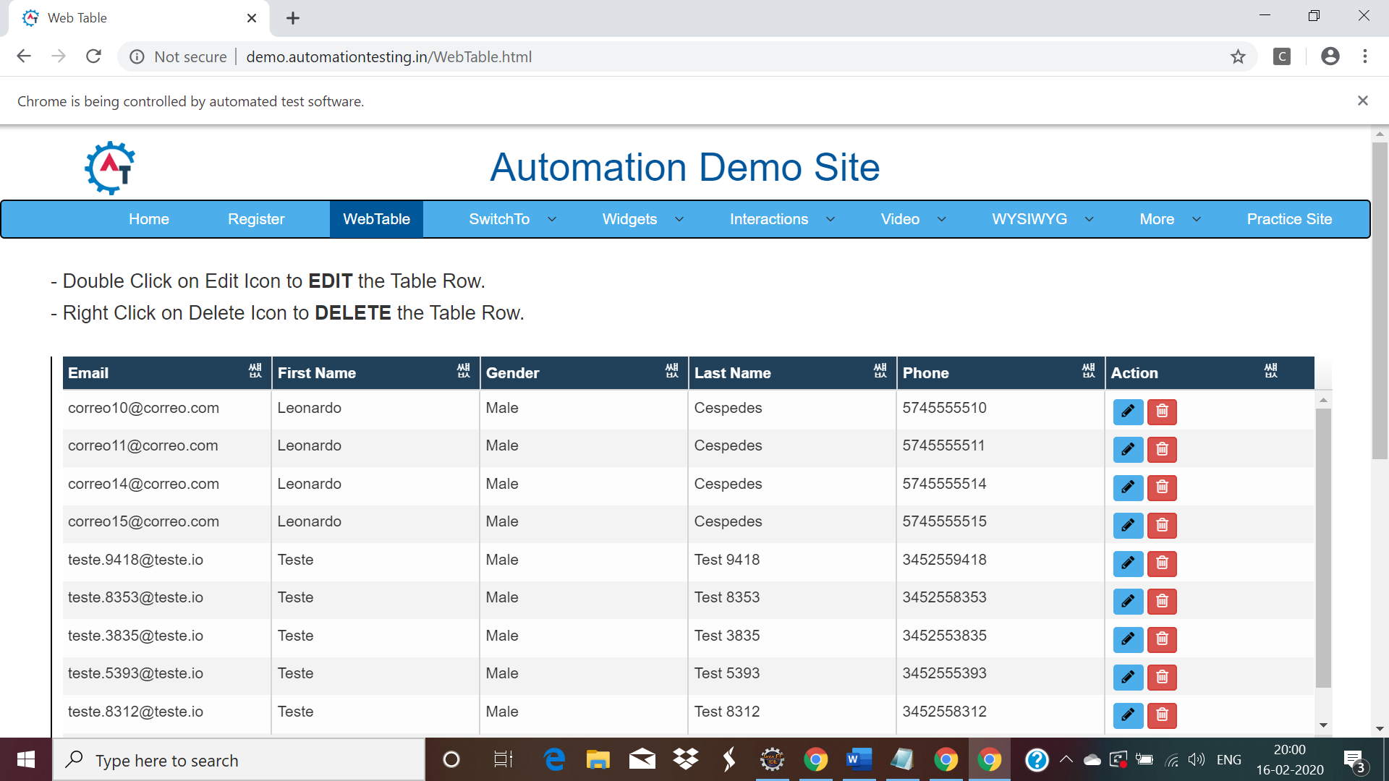

**Day4 Task:**

QUESTION 1

URL : https://www.facebook.com/

NOTE: Print the email and password you are given.

